NUMERICAL INTEGRATION

The term Numerical integration is the numerical evaluation of a definite integral
A = 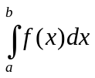
Where ‘a’ and ‘b’ are given constants and f (x) is a function given analytically by a formula of empirically by a table of values. Geometrically, A is the area under the curve y = f (x) between the ordinates x = a and x = b.

But in engineering problem we frequently come across the integrals whose integrand is an empirical function given by a table. In these cases we may use a numerical method of approximate single variable, the process is sometimes called mechanical quadrature.
When we apply numerical integration to the computation of a double integral involving a function of two independent variables it is called mechanical cubature.
The problem of numerical integration, like that of numerical differentiation, is solved by representing the integrand by an interpolation formula and then integrating this formula between the given limits. Thus to find the value of definite integral (or) 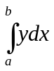we replace the function f(x) (or y) by an interpolation formula, usually one involving differences, and then integrate this formula between the limits a and b. In this way we can derive quadrature formulas for the approximate integration of any function for which numerical values are known.

Of the many possible quadrature formulas, here we shall derive some of the simplest and most useful one.

QUADRATURE FORMULA FOR EQIDISTANT ORDINATES

Consider the Newton’s forward difference formula
y(x) = y(x₀ + rh) = y₀ + ny₀ + 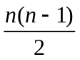² y₀ + 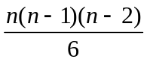³ y₀ +………
y(x) = y(x₀ + uh) = y₀ + uy₀ + 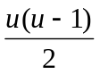² y₀ + 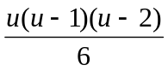³ y₀ +……… (1)
Let y = y (x) ………………………………………………….. (2)
Let us now integrate (2) be the given function.
Let us now integrate (2) oven n equidistant intervals of width h.
i.e.,) 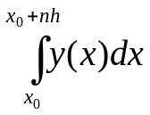 = ?
Let x = x₀ + nh
dx = hdu
when x = x₀ , u = 0.
x = x₀ + nh , u = n
= h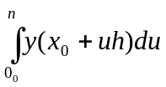
= h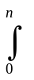(y₀ + uy₀ + ² y₀ + ³ y₀ +………) du
= h(y₀ + uy₀ + 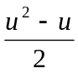² y₀ + 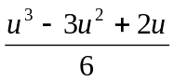³ y₀ +………) du
= h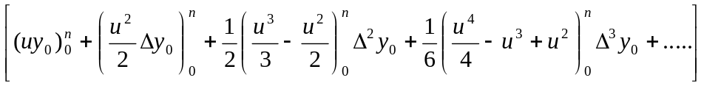
= h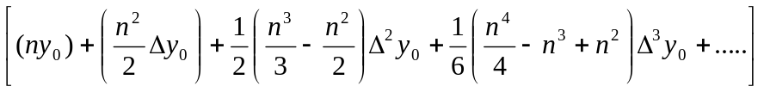
= h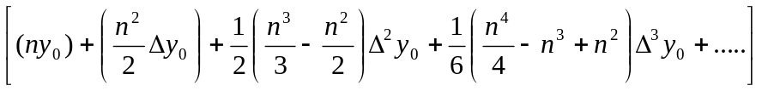..................(A)

This gives the general quadrature formula for equidistant ordinates and is known as Newton – Cote’s formula.

TRAPEZOIDAL RULE
Putting n = 1 in (A), we get
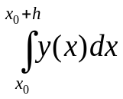= h 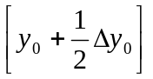
Neglecting higher order differences
= 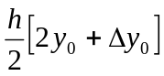
= 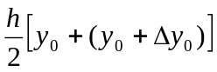
= 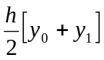

In the interval (x₀ + h, x₀ + 2h), we get

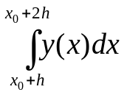= h 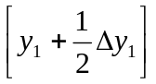
= 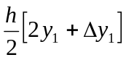
= 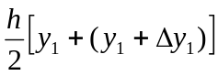
= 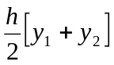
…………………………………………
…………………………………………
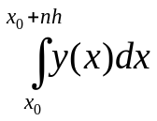 = 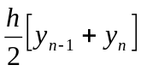
Adding these integral we get
= 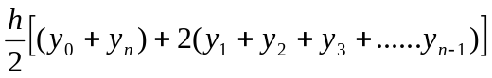
This is called the Trapezoidal rule

SIMPSON’S 1/3 RULE

Putting n = 2 in the above relation (A) and neglecting all differences above the second we get,
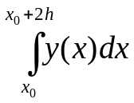= h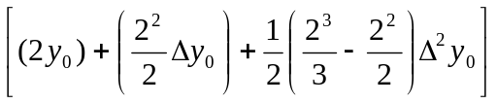
= 2h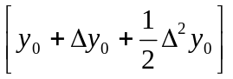
= 2h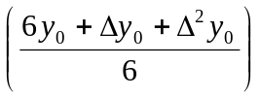
= 2h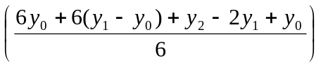
= 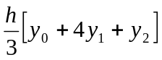
=
Similarly for the next two intervals x₀ +2h to x₀ + 4h we get
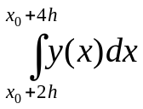= 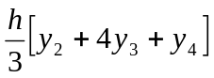
In general
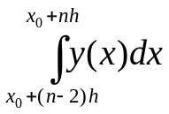= 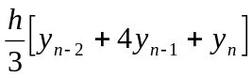
Adding all the above integrals (1), (2), (3) we get
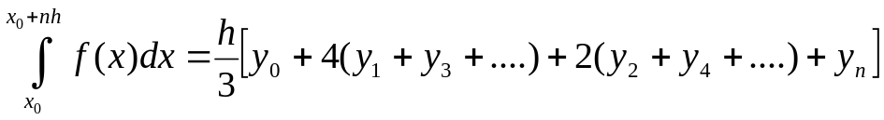
This is called Simpson’s one third rule or Simpson’s rule.
Note 1 : When using this formula the interval of integration must be divided into an even number of subintervals of width h.

Note 2 :
Simpson’s rule is also called a closed formula, since the end point y₀ and y₁ are also included in the formula.

SIMPSON’S THREE – EIGHTH RULE
Putting n = 3 in (A) and neglecting the higher order differences above the third we get
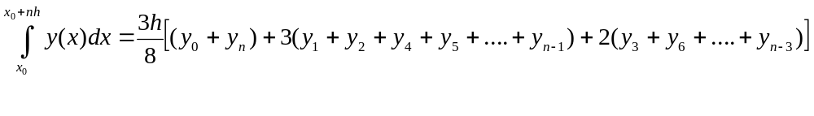This is known as Simpson’s three-eighth rule.
Note 1 :
This method can be applied only it the number of subintervals is a multiple of 3.

Example Problems
Example 1:
Evaluate 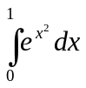 by dividing the range of integration into 4 equal parts using (i) Trapezoidal rule , (ii) Simpson’s rule
Solution :
Here the length of the interval is h = 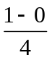 = 0.25.
The values of the function y = 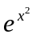for each point of subdivision are given below.

x | 0 | 0.25 | 0.5 | 0.75 | 1
 | 1 | 0.9394 | 0.7788 | 0.5694 | 0.3678

- Trapezoidal rule
= 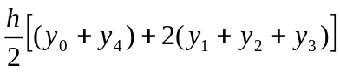
= 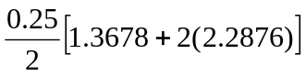
= (0.125)(5.943)
= 0.7428
- Simpson’s rule
= 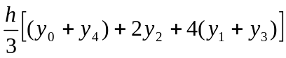
= 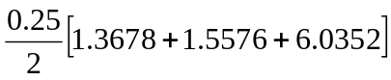
= 0.7467

- Evaluate 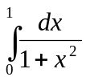, using Trapezoidal rule with h = 0.2. Hence determine the value of .
Solution :
Here h = 0.2. The values of the function y = 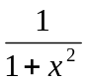 for each point of subdivision are given below.
X | 0 | 0.2 | 0.4 | 0.6 | 0.8 | 1
y = | 1 | 0.9615 | 0.8621 | 0.7353 | 0.6098 | 0.5

By Trapezoidal rule we have
= 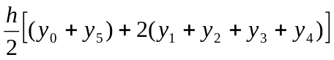
= 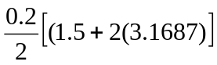
= (0.1)(7.8374)
= 0.78734
We know that
= 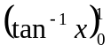
= 
= 4
= 4 (0.78374)
= 3.13496.

3. Find the value of log 2^{1/3} from 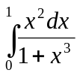 using Simpson’s 1/3 rule with
h = 0.25.
Solution :
Given h = 0.25. The values of the function y = 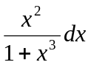 for each point of subdivision are given below.
X | 0 | 0.25 | 0.5 | 0.75 | 1
y = 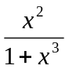 | 0 | 0.06154 | 0.22222 | 0.39560 | 0.5000
By Simpson’s 1/3 rule
=
= 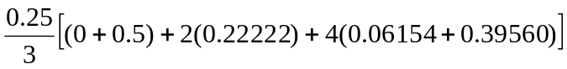
= 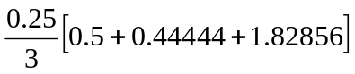
= 0.231083
We know that
= 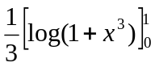
= 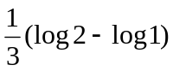
= 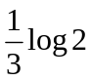
Log 2^{1/3} =
= 0.231083.

